Published by | Editor

HEWI
Marketing

HEWI Heinrich Wilke GmbH
Postfach 1260
D-34442 Bad Arolsen
Phone: +49 5691 82-0
presse@hewi.de
www.hewi.com

Reprint free - specimen copy requested

New Washbasin Models

Ergonomic Handles
The HEWI washbasin product range now includes additional models in tried and tested HEWI quality. The new accessible washbasins are convincingly convenient to use and have a particularly hygienic design. Due to their flat shape, they can be used in both a standing and in a seated position. The washbasin bowl of the new models is extra deep, so that it can hold a particularly large amount of water. The integrated gripping slots are inserted to the left and right of the bowl. They are pleasant to grip due to their ergonomic shape. The integrated gripping slots support the user safely and reliably and make additional installation of hinged support rails superfluous.
Hygienic Design
The new HEWI washbasins not only offer compliant, accessible comfort and convenience, but also have a convincingly hygienic design. They are made of mineral composite and thus have an easy to clean, nonporous surface. An overflow is deliberately omitted, they thus conform to the guidelines for hospital hygiene and infection prevention issued by the Robert Koch Institute. The new models have a rear lip. This lip edge provides an upstand at the wall and prevents standing water on the silicone joint.
Four Variants

The new HEWI washbasins with ergonomic handles and rear lip are available in two different sizes. A round and a rectangular shaped bowl are available to choose from. The washbasin is optionally supplied with one tap hole or for wall-mounted fittings and is available immediately.

Design: HEWI, Bad Arolsen

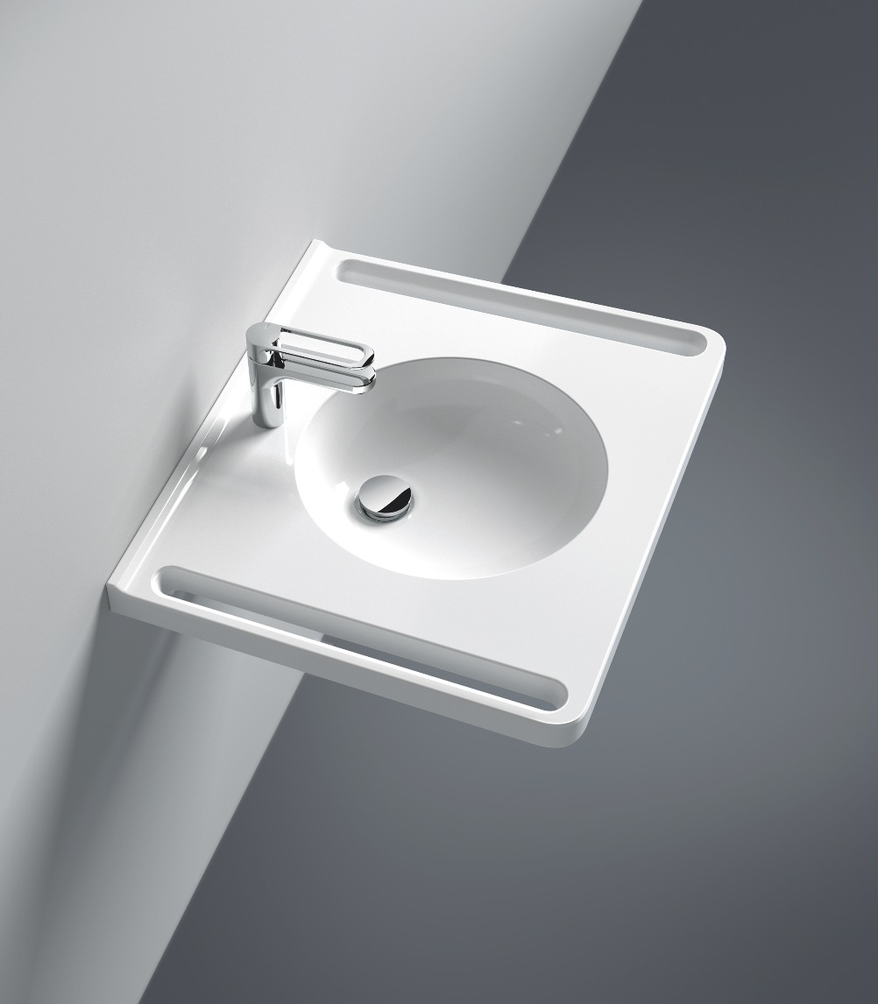
New washbasin models with ergonomic, integrated gripping slots

Further information is available from:

HEWI Heinrich Wilke GmbH
Postfach 12 60
D-34442 Bad Arolsen
Phone +49 5691 82-0
Email: presse@hewi.de
Internet: www.hewi.com

